Page 1 to 5 – Categories, deadline and fee
Page 6 to 9 - Submission form
Page 10 to 16 - Rules & Guidelines
Page 17 to 18 - AI Film Submission Process
Page 19 – Awards & Cash Prize

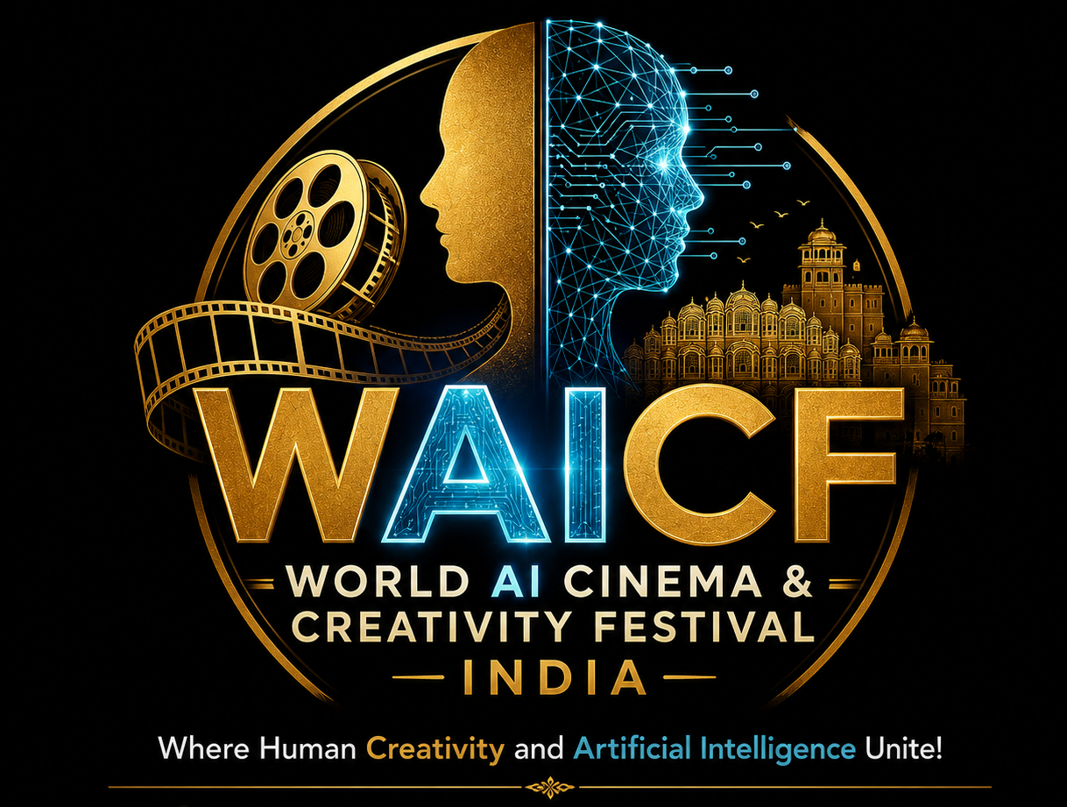

WORLD AI CINEMA & CREATIVITY FESTIVAL (WAICF) – INDIA
Where Human Creativity and Artificial Intelligence Unite!
World's First Complete Cinema Ecosystem — From Traditional Cinema to AI Cinema

SUBMIT YOUR FILM IN ONE OR MORE OF THE 15 CATEGORIES GIVEN BELOW
Organized by JIFF Trust

AI Film Competition Categories
1. Best AI Feature Film
- Feature-length films created with significant AI involvement.
- Fiction, documentary, animation or experimental formats. (Over 45 min)
2. Best AI Short Film
- Short films created using AI tools.
- Duration: 1–45 minutes.
3. Best AI Micro Film
- Ultra-short creative films.
- Duration: Under 5 minutes.
4. Best AI Documentary Film
- Documentary storytelling using AI tools, AI research or AI-based production. (Under 180 min)
5. Best AI Animation Film
- AI-generated animation, 2D/3D animation, virtual characters and worlds. (Under 180 min)
6. Best AI Experimental Film
- Innovative films breaking traditional cinematic formats. (Under 180 min)
7. Best AI Music Video
- AI-created or AI-assisted music videos. (Under 10 min)
8. Best AI Advertisement / Brand Film
- Creative AI films made for advertising, communication and branding. (Under 7 min).

Creative AI Innovation Categories
9. Best AI Screenplay / Story Concept
For innovative AI-assisted storytelling and screenplay development.
10. Best AI Character Creation
For outstanding AI-created digital characters.
11. Best AI Visual Effects & Virtual Production
For filmmakers using AI in VFX, CGI, virtual sets and digital environments.
12. Best AI Cinematic Artwork / Poster Design
For AI-generated film posters and promotional artwork.
13. Best AI Sound & Music Design
For AI-generated background scores, sound design and cinematic audio.
14. AI Film Student Award
For students and young creators exploring AI filmmaking.
15. Future Cinema Award
For groundbreaking work that represents the future direction of filmmaking.
ALL 15 CATEGORIES – ONE SUBMISSION FORM
Competition Categories & Duration
Short Films: Up to 45 minutes
Feature Films: 46 minutes to 180 minutes
ALL FORMATS, ALL GENRES, ALL DURATIONS, AND ALL LANGUAGES ARE ACCEPTED FROM FILMMAKERS ACROSS ALL CONTINENTS.

FILM SUBMISSION DEADLINES
Regular Deadline: August 15, 2026
Late Deadline: October 15, 2026
Extended Deadline: December 5, 2026

SUBMISSION FEE
FEATURE FILMS
(Duration: 46 minutes to 180 minutes)
Regular Deadline: ₹5,000 Indian Rupees OR US $70
Late Deadline: ₹6,000 Indian Rupees OR US $80
Extended Deadline: ₹8,000 Indian Rupees OR US $100

SUBMISSION FEE
SHORT FILMS / DOCUMENTARIES ETC.
(Duration: Up to 45 minutes)
Regular Deadline: ₹2,000 Indian Rupees OR US $35
Late Deadline: ₹2,500 Indian Rupees OR US $45
Extended Deadline: ₹3,000 Indian Rupees OR US $55

ONLINE SUBMISSION
Online submission facility available at:
www.filmdais.com/
For more details:
https://filmdais.com/aifilmfestival.php

PAYMENT OPTIONS
PayPal Payment
Email ID: jiffjaipur@rediffmail.com
PayPal Link:
https://www.paypal.me/JaipurInternational

PayU Payment (Recommended for INR Payments)
https://pmny.in/7Ixh0ZG19owQ

UPI Payment
Pay submission fee through:
PhonePe / Paytm / Google Pay
Mobile No.: 9828934481

BANK DETAILS FOR DIRECT PAYMENT
The entry form/application will be considered valid only after receipt of the applicable film submission entry fee (as per the above deadlines) through Cash, Demand Draft, Cheque, or Bank Transfer in favour of:
Jaipur International Film Festival Trust
Current Account Number: 10331131000292
IFSC Code / Swift / Sort Code: PUNB0103310
Bank Name & Address:
Punjab National Bank (PNB)
Khadi Board Branch, Bajaj Nagar, Near BSNL Office,
J. L. N. Road, Jaipur, Rajasthan, India

INTERNATIONAL BANK TRANSFER DETAILS
For direct deposits from outside India:
SWIFT Code / BIC: PUNBINBBISB
Beneficiary Account Details:
Account Name: Jaipur International Film Festival Trust
Current Account Number: 10331131000292
Bank: Punjab National Bank (PNB)
Khadi Board Branch, Near BSNL Office, Bajaj Nagar,
J. L. N. Road, Jaipur, India

Note: Film submission will be confirmed only after successful receipt of the applicable submission fee and completion of the online submission process.

WORLD AI CINEMA & CREATIVITY FESTIVAL (WAICF) – INDIA
Where Human Creativity and Artificial Intelligence Unite!
World's First Complete Cinema Ecosystem — From Traditional Cinema to AI Cinema

FILM / CREATIVE WORK SUBMISSION FORM
1. Original Title of the Film / Creative Work:
____________________________
Title in English:
____________________________
Subject / Theme of the Film:
____________________________
Production Country:
____________________________
Type of Creation:
AI Generated Film □
AI Assisted Film □
Human + AI Collaboration □
AI Experimental Creation □
2. Premiere Status:
World Premiere □ International Premiere □ Asian Premiere □ Indian Premiere □ Rajasthan/Jaipur Premiere □
3. One-Line Synopsis:
____________________________
4. Director / Creator / Producer / Production Company / Institute Details:
Name:
Address:
Country:
Telephone:
Email:
Website:
Creator / Producer / Production Company / Institute Details:
Name:
Address:
Country:
Telephone:
Email:
Website:
Institute Details (for students):
Name:
Address:
Country:
Telephone:
Email:
Website:
5. Film / Creative Work Details:
A. Synopsis of the Film (Minimum 150 words) - Attach
B. About Director / Creator (Minimum 150 words) - Attach
6. Language Details:
English □ Hindi □ Other: __________
Subtitles: English □ Other □
7. Year of Production:
2024 □ 2025 □ 2026 □ 2027 □
8. Submission Category:
AI Feature Film □ AI Short Film □ AI Micro Film □
AI Documentary Film □ AI Animation Film □ AI Experimental Film □
AI Music Video □ AI Advertisement / Brand Film □
Best AI Screenplay / Story Concept □ Best AI Character Creation □
Best AI Visual Effects & Virtual Production □
Best AI Cinematic Artwork / Poster Design □
Best AI Sound & Music Design □ AI Student Film Award □
Future Cinema Award □
9. AI Technology Details:
AI Tools / Platforms Used:
____________________________
AI Contribution:
Story □ Script □ Image □ Video □ Animation □ VFX □ Editing □ Music □ Character Creation □
10. Production Details:
Creation Tools:
Duration:
Format:
11. Credits & Team Details:
Director:
Producer:
Writer:
AI Artist / Creator:
Cast / Voice Artists:
12. Collaboration Details:
Independent Production □ Crowdfunding □ Co-Production □ AI Technology Partnership □
13. Festival Screening History:
____________________________
14. Awards & Recognition:
____________________________
15. Creation Location / Country:
____________________________
16. Ethical AI Declaration:
I confirm that the submitted work is original and AI tools have been used responsibly.

Signature:
Date: Name & Designation:
Place: Official Stamp/Seal (If any):

WORLD AI CINEMA & CREATIVITY FESTIVAL (WAICF) – INDIA
Where Human Creativity and Artificial Intelligence Unite!
World's First Complete Cinema Ecosystem — From Traditional Cinema to AI Cinema

World AI Cinema & Creativity Festival (WAICF) – India
Where Human Creativity and Artificial Intelligence Unite!
World's First Complete Cinema Ecosystem — From Traditional Cinema to AI Cinema

Submission Rules & Guidelines (A)
1. Eligibility
- World AI Cinema & Creativity Festival (WAICF) welcomes submissions from filmmakers, AI creators, students, artists, researchers, studios, production houses and creative professionals from across the world.

- The festival accepts films and creative works that are:
- AI-generated
- AI-assisted
- AI-enhanced
- Created using AI-based production techniques
- Exploring the relationship between cinema, creativity and emerging technologies

- Submissions are open to:
- Professional filmmakers
- Independent creators
- Students
- AI artists
- Animation creators
- Digital storytellers
- Technology innovators
- There is no restriction on nationality, language, genre or filmmaking style.

3. AI Usage Requirement
- The submitted work must clearly mention the use of Artificial Intelligence in the creative or production process.

- Applicants must provide details regarding:
- AI tools/platforms used
- Creative process
- Human contribution
- Production methodology

- AI can be used for:
- Story development
- Script assistance
- Image/video generation
- Animation
- Visual effects
- Editing
- Sound design
- Music creation
- Character development
- Virtual production

- Human creativity, artistic vision and storytelling value will remain key evaluation criteria.

4. Submission Requirements
Each submission must include:
- Film title
- Director/Creator name
- Country
- Production details
- Film synopsis
- Director/Creator biography
- Poster or promotional artwork (if available)
- Film link (online screener)
- AI tools and technology details
- Making process / AI contribution statement

5. Language & Subtitles
- Films in any language are accepted.
- Non-English films must include English subtitles.
- Subtitles should be clear and professionally prepared.

6. Originality & Copyright
- The applicant confirms that the submitted work is original or legally authorized for submission.
- Participants are responsible for obtaining necessary permissions related to:
- Music
- Images
- Characters
- Copyright material
- Third-party AI assets
- WAICF does not claim ownership of submitted films.

7. Selection Process
- All submissions will be reviewed by an international jury panel consisting of:
- Filmmakers
- AI experts
- Technology professionals
- Creative artists
- Industry representatives
- Selection will be based on:
- Creativity
- Storytelling quality
- Innovation
- Effective use of AI technology
- Artistic expression
- Future impact
- The jury's decision will be final.

8. Screening & Promotion Rights
By submitting a film, participants grant WAICF permission to:
- Screen selected films during the festival
- Use film posters, stills and trailers for promotional purposes
- Promote selected works through festival platforms and media channels
No commercial rights are transferred.

9. Awards & Recognition
Selected winners will receive:
- Official WAICF Award Certificate
- Trophy/Award (where applicable)
- International recognition
- Promotion through WAICF, Film Dais and associated global cinema platforms

10. Ethical AI Guidelines
WAICF encourages responsible and ethical use of Artificial Intelligence.
Submitted works should respect:
- Human creativity
- Copyright principles
- Cultural diversity
- Responsible technology practices
AI should be used as a creative partner to expand imagination and storytelling possibilities.

11. More Rules & Regulations (B)
- All AI-generated, AI-assisted, Human + AI collaborative films, documentaries and creative works produced between January 2024 to February 2027 with a running duration of 1 minute to 180 minutes are eligible for the festival and awards.
- Entries of all films/creative works (hereafter collectively called Films) shall be accepted through Online Screener, Digital File Submission or Secure Online Link with Password.
- After nomination/selection, participants may be required to submit the final screening file without watermark, advertisements or promotional interruptions.
- If a film is not eligible to be entered in any specific category, it may be considered for Best AI Creative Film / Critics Choice Award at the discretion of the festival jury.
- A complete list of officially selected films in each category shall be published on the official festival website.
- Applicants shall be responsible for providing all required submission materials, including film details, synopsis, creator profile, poster, still photographs, credits and AI technology details.
- Transportation, courier, insurance, customs duties or any other charges related to submission materials from the country of origin to the festival office shall be borne by the applicant.
- Government censorship certification shall not be applicable to films/videos submitted to the festival.
- Entry forms with incorrect, incomplete, inadequate, illegible or ambiguous information may not be considered for selection.
- The festival reserves the right to classify submitted films into appropriate categories according to the festival guidelines.
- Awards and certificates shall be awarded to the Director(s), Producer(s), Creator(s) or eligible participants of the film.
- Any duties, taxes, courier charges, transportation expenses or other charges related to receiving trophies/awards outside the festival venue shall be borne by the recipient.
- All shortlisted/selected entries will receive an official festival certificate.
- Participants may submit one or more entries. There is no limit on the number of submissions.
- Once a film is officially selected and included in the final festival programme, it shall not be allowed to be withdrawn under any circumstances until the completion of the festival.
- The festival may organise maximum up to five screenings of any selected film as per international festival practices.
- Online preview links of films may be submitted for selection purposes through a secure password-protected link as per the announced submission deadline.
- Submission of a film to WAICF implies acceptance of all festival rules and regulations.
- The decisions of the Festival Authority and Jury regarding selection, awards, category classification and interpretation of any clause shall be final and binding on all participants.
- WAICF encourages responsible, ethical and creative use of Artificial Intelligence while celebrating innovation, imagination and the future of cinema.

For more: https://filmdais.com/aifilmfestival.php

AI FILM SUBMISSION PROCESS
Filmmakers may send their AI Film entry along with the required documents and online screener details to the Festival Office at the following address:
Submission of AI Film Entries
AI Film entries can be submitted through Online Submission, Email Submission, or by Post/Courier.

OPTION 1: ONLINE PLATFORM SUBMISSION
Submit your film/entry through recognized online submission platforms such as:
- FilmFreeway, WFCN, Festhome, Other approved submission platforms
More details: https://filmdais.com/aifilmfestival.php

OPTION 2: EMAIL SUBMISSION WITH ONLINE SCREENER
Send the following materials by email:
- Completed Entry Form (duly signed on the last page; scan or photograph and attach with email)
- Online Screener Link (YouTube / Vimeo / WeTransfer etc.)
- Password (if required)
- Film details as mentioned in the submission checklist
- Proof of Entry Fee Payment
Send to: waicfindia@gmail.com

OPTION 3: POST / COURIER SUBMISSION
Send the following materials by Post/Courier:
- Completed Entry Form
- Film Copy (DVD / Blu-ray / DCP)
- Entry Fee Payment Proof (Cheque/DD/Bank Transfer Details)

Send to:

WORLD AI CINEMA & CREATIVITY FESTIVAL (WAICF) – INDIA
F1, T-138, Narayan Vihar, Near SBI & Bhakhar Paradise
Gopalpura Bypass Road, Jaipur – 302 020 Rajasthan, INDIA
Mobile: +91-8003937961
Email: waicfindia@gmail.com

ACCEPTED SUBMISSION FORMATS
For pre-selection and preview, WAICF accepts online screeners through:
- YouTube Links
- Vimeo Links
- WeTransfer Links
- Other secure online viewing platforms
Films already released on YouTube are also eligible for submission.

SUBMISSION CHECKLIST
Please ensure the following materials are submitted:
- Complete Entry Form with Signature
- Film Screener Link / 2 DVDs / Blu-ray / DCP (as applicable)
- Film Synopsis (150 words and short synopsis of 20 words)
- Director’s Bio Data (approximately 150 words)
- Entry Fee Payment Proof
- Director’s Photograph
- Minimum Two Film Stills
- Minimum Two Production Stills
- Film Poster (if available)
- Censorship Certificate (if available from Government of India)
- Customs Invoice (for international submissions)
For international shipments, the package should be clearly marked:
“FESTIVAL MATERIAL – CULTURAL VALUE”

NOTIFICATION DATE: December 21, 2026
Festival Programme will be live on the website: December 21, 2026

AWARDS:
TOP 3 TO 5 WINNERS WILL BE SELECTED IN EACH CATEGORY
CASH PRIZE:
Up to ₹₹25,00,000 (INR), depending on sponsorship support and funding availability.
SPECIAL AWARDS
In addition to the above awards, the Festival may confer the following honorary distinctions:
• AI Visionary Award • AI Pioneer Award
• Future of Cinema Award • AI Innovation Excellence Award
• Young AI Creator Award • Outstanding Achievement in AI Cinema Award
• Lifetime Achievement in AI Cinema Award
The Festival Authorities and Jury reserve the right to institute additional awards and recognitions as deemed appropriate.

FESTIVAL VISION
"World’s First International AI Film Festival dedicated to AI Cinema, Creative Intelligence and the Future of Storytelling."
A global platform connecting:
JIFF – Jaipur International Film Festival
Celebrating Global Cinema, Cultural Diversity & Filmmaking Excellence
NDFF – New Delhi Film Festival
Connecting National & International Film Movements
Jaipur Film Market (JFM)
Creating Global Film Industry & Co-production Opportunities
Film Dais – AI & Digital Film Market & Expo
Building the Future of Digital Cinema and AI Ecosystem
WAICF – World AI Cinema & Creativity Festival
Where Human Creativity and Artificial Intelligence Unite
………………………………………………………………….end……………………………………………………………………..

